Day 1 : 10 Sep 2024

Java is platform independent and pure object oriented programming language.

J2SE J2EE J2ME

JavaSE JavaEE JavaME

JSE JEE JME

Java Standard edition Java Enterprise Edition Java Micro Edition

Using JSE we can create desktop or standalone application. The application running on only single machine is known as desktop application.

Basic java programming

OOPs concept, object, class, Encapsulation, polymorphism, abstract and inheritance etc.

Exception handling to handle to error

Multi threading optional

Io package

Collection framework like data structure.

Jdbc to connect database like mysql or oracle.

JEE : Servlet, JSP (Java Server pages) and EJB (Enterprise Java Bean) etc.

Using servlet, jsp and ejb we were/are creatine enterprise level web application using java technologies.

JME : Java micro edition : android is base upon java technologies.

Framework : Framework provided set of api (application programming interfaces). It can class or interfaces. Which internally connected with each other to perform specific task. Design pattern: best practise or solution for repeating problem. Singleton design pattern(creating only one object of any class). factory design pattern (the method responsible to create the object etc). The implementation of design pattern taken care by framework. Framework is like a template or protocol etc. framework takes are 70 to 80% task. But framework is not final product it prototype. Now we need to write 20 to 30% code to complete project.

Angular framework

.net framework

Django with python framework

View -🡪 HTML or JSP (Java Server pages)

Controller -🡪 Servlet

Model -🡪EJB (Enterprise Java Bean) or normal java classes.

Struts framework : Stuts is an open source web framework provided by Apache.

Which internally follow MVC (model view controller) design pattern. They provided lot of classes to improve view layer, controller layer and model layer. Struts is known as control centric framework.

JSF framework : Java Server Faces. It is an open source web framework provided by oracle. Which internally followed MVC . They provided lot of classes to improve view layer, controller layer and model layer. JSF is known as view centric framework.

Angular or React JS Vs JSF

Spring Framework : Spring is an open source light weighted layer architecture or onion architecture framework.

Spring framework Vs EJB

Spring framework echo system or modules

1. Spring core
2. Spring context
3. Spring web or mvc (model view controller)

Spring is known as model centric framework.

1. Spring dao (data access object )
2. Spring orm ( object relation mapping)
3. Spring rest (web service )
4. Spring security
5. Spring cloud
6. Spring boot
7. Spring micro service

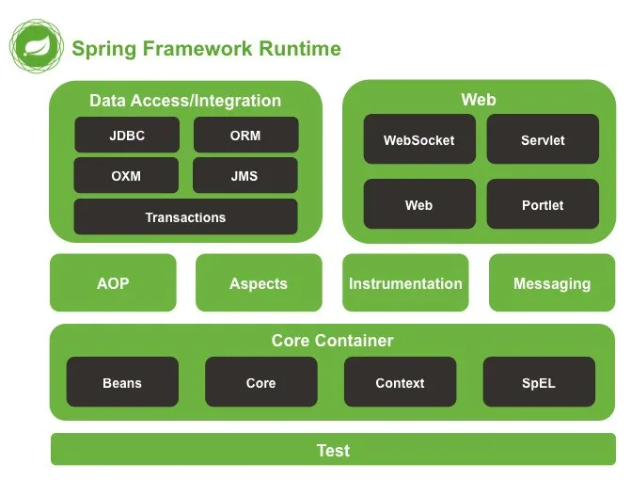

Spring Core and Context

IOC : Inversion of control

DI : Dependency Injection

IOC : IOC is programming design pattern. It is a concept. According to IOC in place of creating any resources like object, database connection, security, threads explicitly allow to create by container(run time environment). If container create it will maintain properly. If we create may be we maintain or not. But container take care life of the resource properly. We need pull from base upon requirement use it and leave it.

To run the java application in our machine need JRE (Java run environment).

To run servlet and jsp program we need web server. Web server container web container which is responsible to run servlet and jsp program.

DI : Dependency Injection : Using DI we can provide the implementation for IOC.

There are two type of DI.

Constructor base DI

Setter base DI

Pulling any resources from container using constructor base or setter base.

To achieve DI using constructor base or setter base we need to configuration

1. Using XML file
2. Using annotation base

Creating spring project we generally use build tool

1. Maven : xml base in maven we use pom.xml file to download required dependencies.
2. Gradle : xml less to xml file. We use build file to download the dependencies.